**Circuit and System-I Lab**

**LAB # 08**



**Spring 2022**

Submitted by: Ali Asghar

Registration No.: **21PWCSE2059**

Class Section: **C**

“On my honor, as student of University of Engineering and Technology, I have neither given nor received unauthorized assistance on this academic work.”

Student Signature: ______________

Submitted to:

**Engr. Faiz Ullah**

9 June, 2022

Department of Computer Systems Engineering

**ASSESSMENT RUBRICS LAB # 8**

**Mesh Current Analysis using PSPICE**

|  |  |  |  |  |
| --- | --- | --- | --- | --- |
| **LAB REPORT ASSESSMENT** | | | | |
| **Criteria** | **Excellent** | **Average** | **Nill** | **Marks Obtained** |
| 1. **Objectives of Lab** | All objectives of lab are properly covered  [Marks 0.5] | Objectives of lab are partially covered  [Marks 0.25] | Objectives of lab are not shown  [Marks 0] |  |
| 1. **Mesh Current Analysis**   **(Theory, Circuit Diagram )** | Brief introduction about Mesh Current Analysis (what is Mesh current analysis, What are meshes, How to apply KVL equations in each mesh) is shown along with properly labeled circuit diagram  [Marks 1] | Some of the points about Mesh Current Analysis are missing and circuit diagram is not properly labeled  [Marks 0.5] | Introduction about Mesh Current Analysis and circuit diagram is not shown  [Marks 0] |  |
| 1. **PSPICE**   **Simulator** | Brief introduction of PSPICE simulator  [Marks 1] | Brief introduction of PSPICE simulator  Is not shown  [Marks 0] | |  |
| 1. **Procedure** | All experimental steps are shown in detail along with how to verify Mesh Current Analysis.  [Marks 1.5] | Some of the experimental steps are missing  [Marks 1] | Experimental steps are missing  [Marks 0] |  |
| 1. **Observations & Calculations** | Mathematical calculations are shown and comparison with PSPICE results.  [Marks 5] | Mathematical calculations are shown but no comparison with PSPICE results  [Marks 2.5] | No mathematical calculations are shown  [Marks 0] |  |
| 1. **Conclusion** | Conclusion about experiment is shown  [Marks 1] | Conclusion about experiment is partially shown  [Marks 0.5] | Conclusion about experiment is not shown  [Marks 0] |  |
| Total Marks Obtained:__________  Instructor Signature: ______________________ | | | | |

**Title:**

**Mesh Current Analysis using PSPICE**

**Objectives:**

* To Know About Mesh Current Method.
* To Verify Mesh Current Analysis Method.

**MESH CURRENT ANALYSIS :**

Mesh analysis (or the mesh current method) is a method that is used to solve planar circuits for the currents (and indirectly the voltages) at any place in the electrical circuit.

**PLANAR CIRCUITS:**

Planar circuits are circuits that can be drawn on a plane surface with no wires crossing each other.

**MESH:**

A loop which doesn’t enclose any other loop.

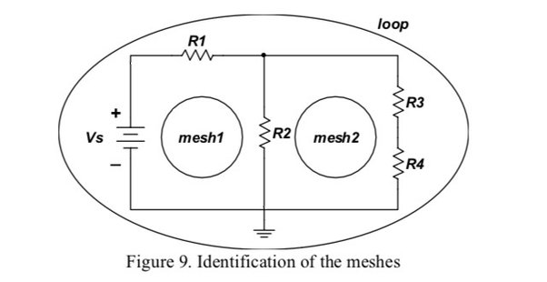

Figure 1

Figure 1 shows the basic main difference between a loop and a mesh.

**Steps of Mesh CURRENT Analysis:**

Following are the main steps involved in mesh current analysis

1. Identify the number of basic meshes.
2. Assign a current to each mesh.
3. Then apply Kirchhoff’s Voltage Law (KVL) in order to get an equation in terms of loop current.
4. Then solve the system of equation(s) obtained as a result of the KVL.

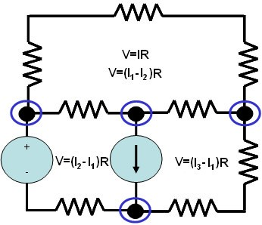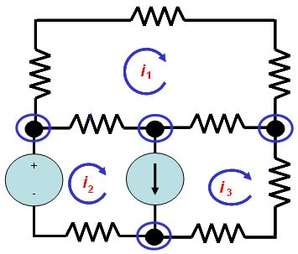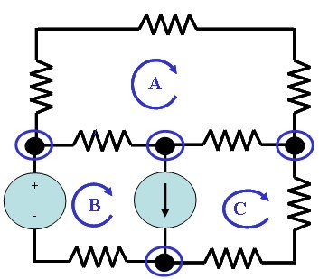

Step 1 Step 2 Step 3

**PSPICE:**

**PSpice** is a SPICE analog circuit and digital logic simulation software that runs on personal computers, hence the first letter "P" in its name. It was developed by MicroSim and is used in electronic design automation. MicroSim was bought by OrCAD which was subsequently purchased by Cadence Design Systems. The name is an acronym for Personal Simulation Program with Integrated Circuit Emphasis. Today it has evolved into an analog mixed signal simulator.

OR

“PSPICE is a circuit analysis tool that allows the user to simulate a circuit and extract key voltages and currents.”

**VERIFICATION IN PSPICE:**

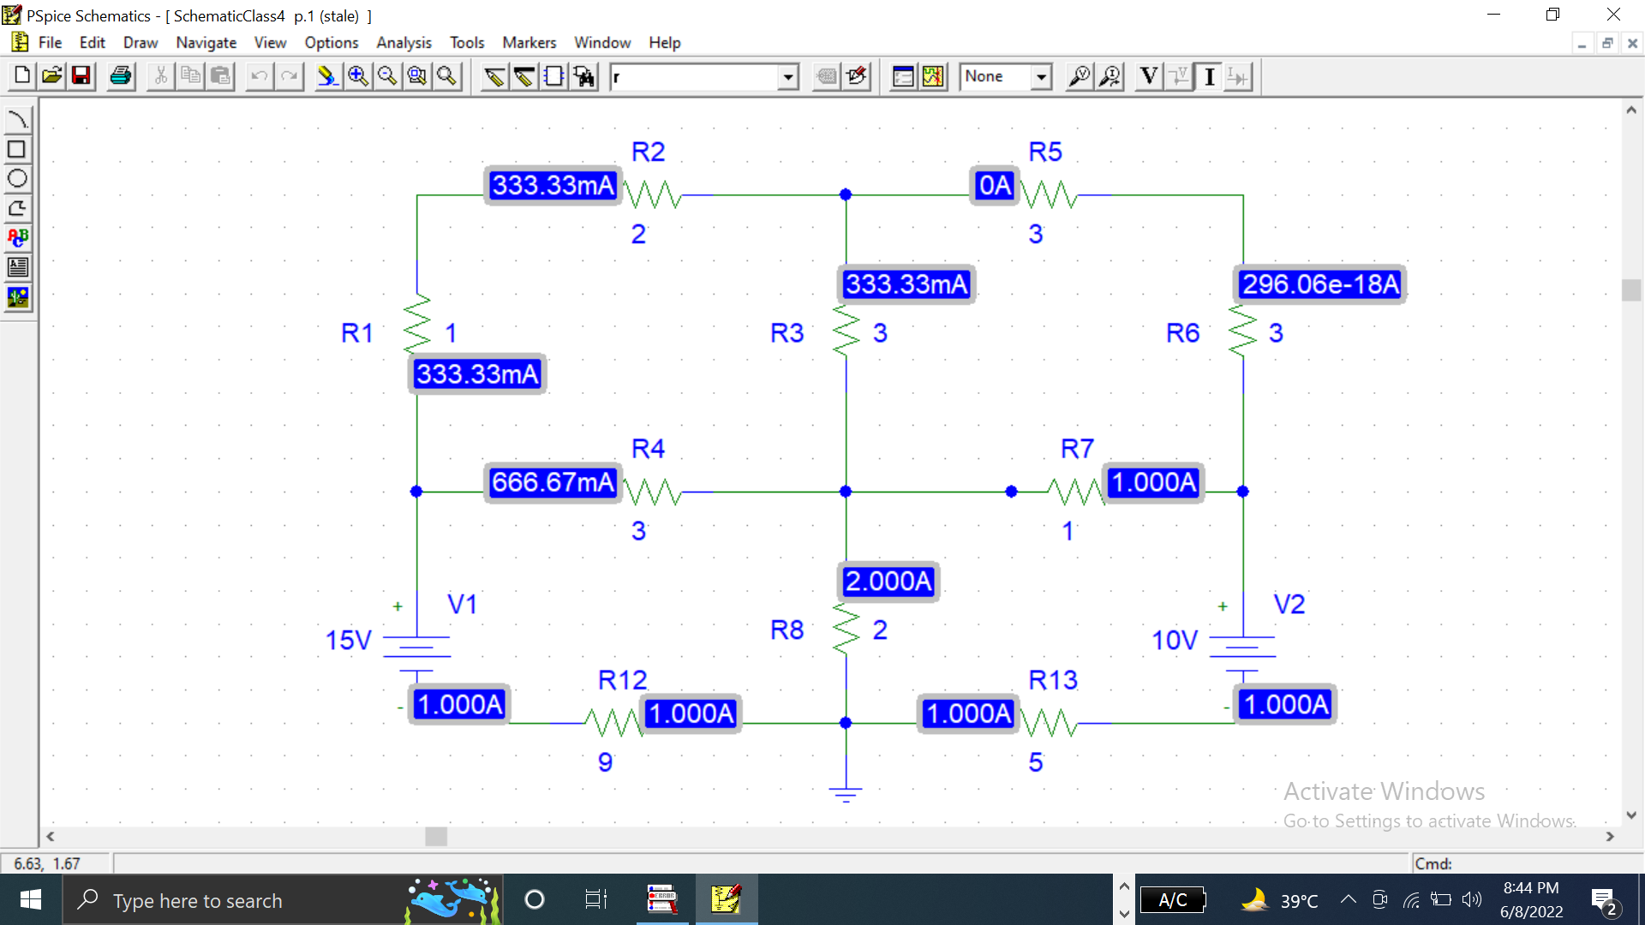

The PSPICE Values for all meshes are:

I1 = 0.333A, I2 =0A, I3 =1A and I4 =1A

**PROCEDURE:**

1. Open schematic program of PSpice
2. Click on the “Get New Part” button on the toolbar
3. Type ‘r’ in the search bar and place the eight resistors on the white sheet
4. Type ‘vdc’ in the search bar and place two of them on the white sheet
5. Type ‘gnd-earth’ and place it on the white sheet
6. Now arrange these components on the white sheet according to the circuit diagram as following.
7. After arranging click on simulate button and the following results are generated

**Mathematical Observation:**

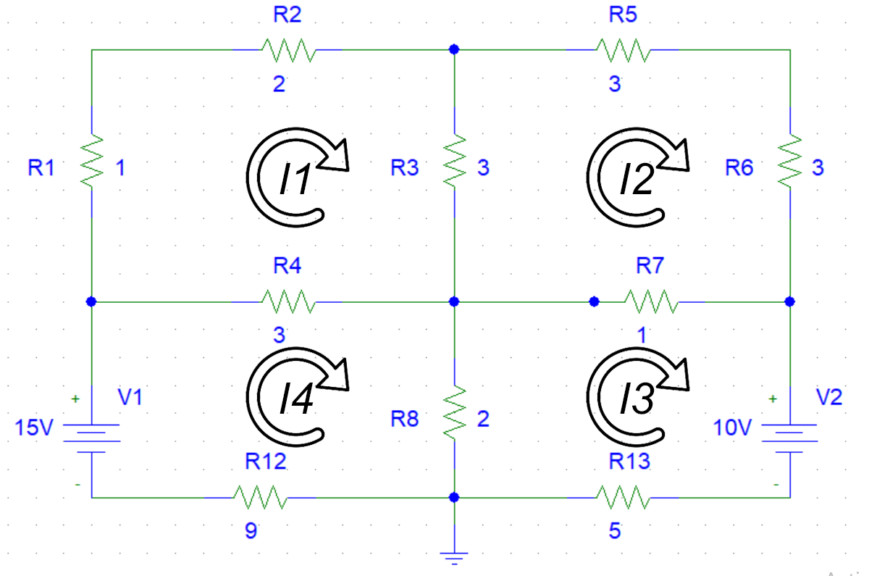

**Mesh 1:**

For Mesh 1, the Mesh current equation will be:

$$3i_{1}-i_{2}-i_{4}=0$$

**Mesh 2:**

For Mesh 2, the Mesh current equation will be:

$$-3i_{1}+{10i}_{2}-i_{3}=0$$

**Mesh 3:**

For Mesh 3, the Mesh current equation will be:

$$-i_{2}+8i_{3}-2i_{4}=-10$$

**Mesh 4:**

For Mesh 4, the Mesh current equation will be:

$$-{3i}_{1}-2i_{3}+14i_{4}=15$$

**Final calculations:**

By solving above 4 equations, the values of I1 , I2 , I3 and I4 are known. i-e

I1 = 0.333A, I2 =0A, I3 =1A and I4 =1A

|  |  |  |  |  |
| --- | --- | --- | --- | --- |
| S.No. | Currents | Calculated Value | PSPICE Value | Error |
| 1 | I1 | 0.333A | 0.333A | 0% |
| 2 | I2 | 0A | 0A | 0% |
| 3 | I3 | -1A | 1A | 0% |
| 4 | I4 | 1A | 1A | 0% |

**CONCLUSION:**

In accordance with the Mesh Current Analysis, we made use of Kirchhoff’s Voltage law to arrive at a system of equations which aims to calculate the currents in a mesh. The calculated current values were then verified in PSPICE Simulator. PSCPICE Confirmed the calculations of Mesh Current Analysis. No Errors were arise in the calculated values.